Reception Newsletter
Spring Term 2 – 2023/2024
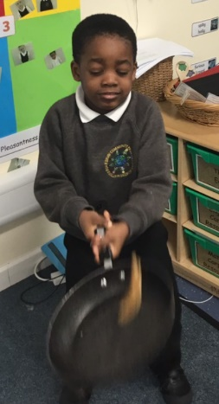
Welcome back! We hope you have had a lovely, relaxing break. Last half term we had so much fun! We learnt about Chinese New Year, where we tried lots of different Chinese food and took part in our own dragon dance parade. In our topic lessons, we discovered how the Polar Regions and Middleton are different.
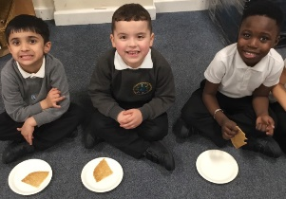

Topic  What happened long ago?  This term we will be looking at the past and comparing it to life today. We will explore what it was like to live in the past and how toys and games have changed over the years.  We will be looking at how we know someone or something is from the past by looking at similarities and differences.  If anyone has any old toys or artefacts from the past that we could look at during this topic then we would be extremely grateful. Please send them into school. | Important Dates  Friday 1st March – St David’s Day  Thursday 7th March – World Book Day  Sunday 10th March – Mother’s Day  Friday 8th – Sunday 17th March – Science Week  Friday 15th March – Comic Relief  17th March – St Patrick’s day  Thursday 30th March – School closes for Easter  Monday 15th April – School re-opens for Summer 1
Maths in Reception
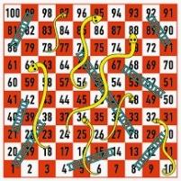
A great way to help your child with mathematics is to play simple board games with them. Encourage them to recognise numbers by sight on a dice and just say the number without counting. Encourage careful counting as they move their playing piece along the board, saying 1 number for each square as they move. Board games also support turn taking and managing emotions as well as improving fine motor skills as they pick up small counters and dice

Phonics at Home
phonicsplay.co.uk is a great and fun website for the children to practise their phonics skills. There are lots of interactive games that the children can access to reinforce all the skills we have been learning in school.

PE
Our PE sessions continue to be on Thursdays. Blue Tang and Clownfish have it on alternative weeks. Please make sure that your child has a full PE kit in school, including trousers in case it is a cold day.
Reading
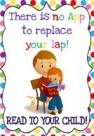
Please remember to read with your child every night. Reading books are
changed once a week. Your child will receive a phonics reading book and a library book for you to share. Children need to practice reading their phonics book multiple times so they can recognise the words in it and build up their confidence and fluency. If you would like an additional book each week for your child to read at home please speak to a member of staff. It is really important that you write in your child’s reading record so we can keep an accurate record of your child’s home reading.

Please continue to share work and experiences on tapestry. The children really enjoy sharing them with the class. Each day we make time to share our “super learning,’ and this can be things they have done at home too.
Thank you
It was lovely to see so many parents attend our session for Mental Health Week. We hope to invite you into school again later this half term. We are so grateful for all the extra support you are providing at home which is helping your child to reach their full potential.
Please remember to continue to talk to your child, ask them questions and read them a bedtime story each night.
Remember if you have any questions then please speak to your child’s teacher.

