Boarshaw Primary School – Science
Topic: Living things and their habitats. | Strand: Biology |  |  |  |  | Year 2
What should I already know? |  |  | Key Knowledge |  | Vocabulary
- There are five types of vertebrates (mammals, fish, reptiles, amphibians, birds).  - Some animals are suitable to be kept as pets but others are not.  - Animals including humans have offspring which grow into adults.  - The names of the main body parts (eg neck, elbow, knee, eyes etc).  - How to group animals according to what they eat or by their appearance, the sounds they make or textures of skin / fur.  - Which things are living, dead or have never been alive. |  |  | 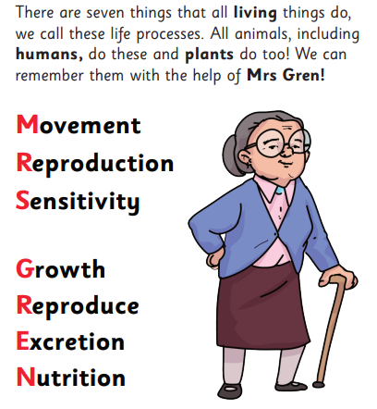  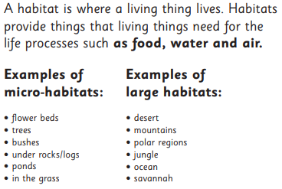  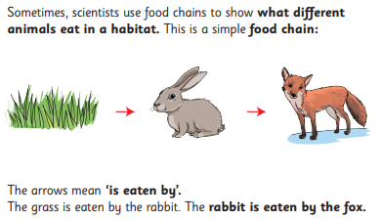 |  | 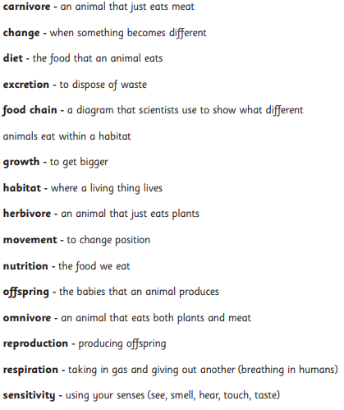
Key Knowledge

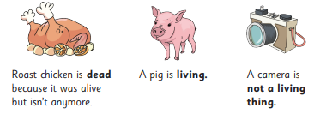
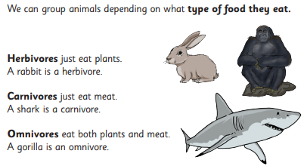

Boarshaw Primary School – Science
Topic: Animals including humans |  | Year 2
End of Unit
Question 1:  What is a habitat?  a) Something that shoes what different animals eat  b) Somewhere a living thing lives.  c) Something that only eats plant  d) One of the seven life processes  e) Don’t know |  |  | Question 4:  What is an omnivore?  a) Something that just eats plants  b) Something that just eats meat  c) Something that eats plants and meat  d) Something that only drinks water  e) Don’t know
Question 2:  Which of the following applies to a rock?  a) Living  b) Dead  c) Never alive  d) Don’t know |  |  | Question 5:  Which of these are examples of micro-habitats? (Circle 2)  a) Jungle  b) Pond  c) Under a rock  d) Desert  e) Don’t know
Question 3:  Which of the following are life processes? (Circle 2)  a) Sensitivity  b) Flying  c) Swimming  d) Growth  e) Don’t know |  |  | Question 6:  Which of these statements is true?  a) A cow’s habitat is the savannah.  b) The arrow on a food chain means “eaten by”  c) Living things do not adapt to their habitats  d) Only humans do the seven life processes  e) Don’t know

