Boarshaw Primary School – Science
Topic: Animals including humans | Strand: Biology |  |  |  |  | Year 2
What should I already know? |  |  | Key Knowledge |  | Vocabulary
- There are five types of vertebrates (mammals, fish, reptiles, amphibians, birds).  - Vertebrates are animals that have a backbone.  - Some animals are suitable to be kept as pets but others are not.  - Some animals give birth to live young but others lay eggs.  - The names of the main body parts (eg neck, elbow, knee, eyes etc).  - How to group animals according to what they eat or by their appearance, the sounds they make or textures of skin / fur. |  |  | 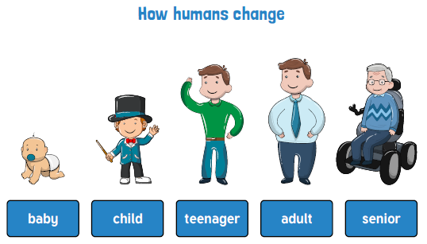  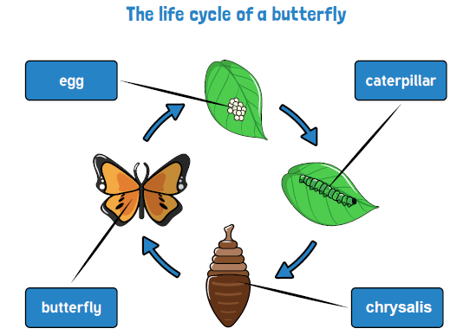  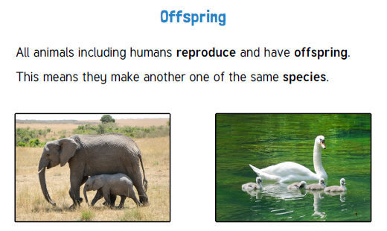 |  | 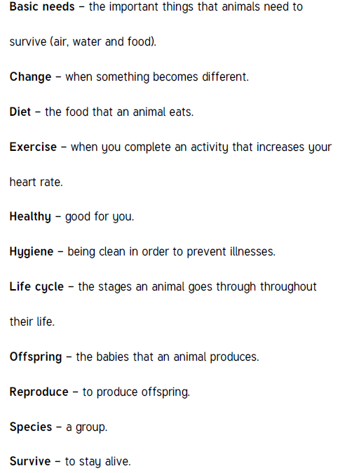
Key Knowledge

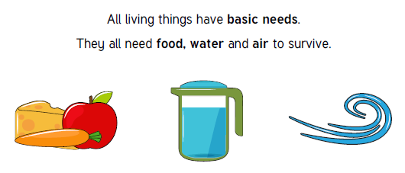

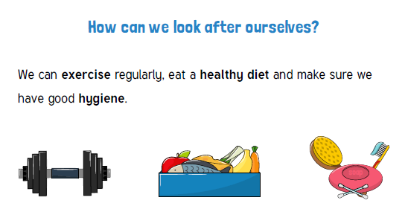

Boarshaw Primary School – Science
Topic: Animals including humans |  | Year 2
End of Unit
Question 1:  What are the essential things that all animals need to survive? (circle 2)  a) Water  b) Friends  c) Air  d) Milk  e) Don’t know |  |  | Question 4:  In the human life cycle what stage comes after baby?  a) Toddler  b) Elderly  c) Adult  d) Teenager  e) Don’t know
Question 2:  What are the things humans can do to stay healthy? (circle 2)  a) Exercise  b) Eat a balanced diet  c) Watch TV daily  d) Read a book every week  e) Don’t know |  |  | Question 5:  Which of these show good standards of personal hygiene? (circle 2)  a) Brush teeth once a week  b) Wash hands regularly throughout the day  c) Brush hair twice daily  d) Change clothes once a week  e) Don’t know
Question 3:  What does the word ‘offspring’ mean?  a) A form of gymnastics  b) To turn on and then off  c) A season of the year  d) A person’s children or an animal’s young  e) Don’t know |  |  | Question 6:  Which of these statements is false?  a) After exercise my heart beats faster  b) After exercise my heart beats slower  c) After exercise I feel sweaty  d) After exercise I breathe quicker/pant  e) Don’t know

