Boarshaw Primary School – Geography
Topic: Seaside |  |  | Strand: Locational Knowledge &  Human and Physical Geography |  |  |  |  |  | Year 2
What should I already know? |  |  | Geographical skills and fieldwork |  |  |  |  | Vocabulary
- The country I live in is England.  - I live in Manchester which is a city in England, My school is in Middleton.  - The similarities and differences between Middleton and Lytham St Annes.  - England is a country in the UK (England, Scotland, Wales and Northern Ireland).  - London is the capital city of England.  - Manchester is an inland area of the UK. |  |  | - Locate seaside features using grid referencing  - Use Google Earth to locate our nearest Seaside resort and other UK seaside resorts. Such as Blackpool and Lytham St Annes. What features can we observe? What are the similarities and differences?  - Visit Beach and explore land use (beach, entertainment areas, housing etc).  - Describe the human and physical features of typical UK seaside resorts- Lytham St Annes.  - Locate seaside resorts in relation to each other using the points of the compass.  - Identify similarities and differences Manchester (non-coastal) and Lytham St Annes (coastal) areas. |  |  |  |  | aerial view a view from above  atlas a collection of maps of the earth  coastal an area of land close to the sea  compass point points relating to North, South, East, West  country an area of land that is controlled by its own government  estuary the tidal mouth of a large river, where the tide meets the stream  fishing an industry based on the selling of fish to others  human features features of land that have been impacted by human activity – farm, house, harbor, port  industry the features of the land/area which help to create raw materials for different jobs eg fishing, tourism, coastguard  physical features natural features of land – beach, cliff, coast, sea  port a harbour area where ships unload goods or passengers  resort a place that is visited for holidays  river a large, natural stream of fresh water that flows into the sea  sea a large expanse of salty water that surrounds the earth’s land masses  tourism the commercial organization and operation of holidays and visits to places of interest  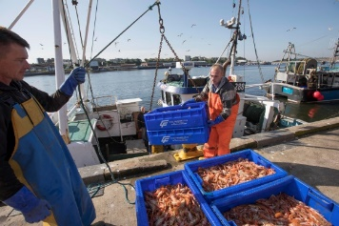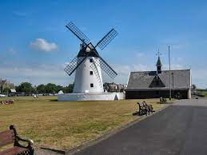
Which are the popular Seaside resorts of the UK

Popular UK seaside resorts include:
- England – Great Yarmouth in Norfolk, Skegness in Lincolnshire, Weymouth in Dorset, Seaburn in Tyne & Wear, Southport in Merseyside, Bridlington in Yorkshire, Blackpool and Lytham.
- Wales – Conwy, Porthcawl, Tenby, Barry Island, Rhyl, Llandudno.
- Scotland – Saltcoats, Largs, Dunoon, Kilchattan Bay, Dunbar.
- Northern Ireland – Carrickfergus, Portstewart, Ballycastle and Portrush.

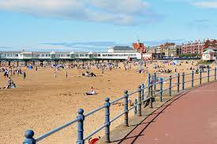
 |  |  | Features of Seaside resorts
Human
- Land use – hotels, houses, marina, life boat stations, fishing quays, docks, farms, harbours.
- Recreational use of land – shopping, library, church, community centres.
- Industry – fishing hoteliers, shops, tourist attractions, employment
Physical
- Coast, beach, woodlands, cliff, rivers, sea, estuary.

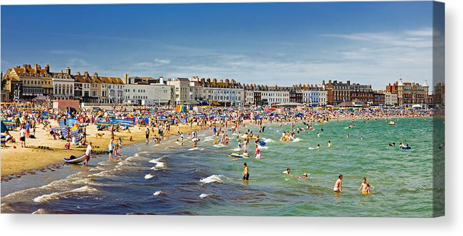
 | Boarshaw Primary School – Geography
 | Topic: Seaside |  |  |  | Year 2
 | End of Unit
 | Question 1:  Which of these are human features of typical seaside resorts? (circle 2)  a) Beach  b) Pier  c) Cliff  d) Shops  e) Don’t know |  |  |  |  | Question 4:  Which of these best describes a coastal town?  a) A town that has lots of houses  b) A town that is by the sea  c) A town with a large park  d) A town that is built in the mountains  e) Don’t know
 | Question 2:  Which of these are physical features of typical seaside resorts?  (circle 2)  a) Cliff  b) Harbour  c) Sea  d) Hotels  e) Don’t know |  |  |  |  | Question 5:  What would you not expect to see in a non-coastal town?  a) Shops  b) Cinemas  c) A sea harbour  d) Parks with sandpits  e) Don’t know
Question 3:
What is an aerial view?

a) What you see from the ground
b) What you see from above
c) What you see when you are lying down
d) What you see when you are underwater
e) Don’t know

