Boarshaw Primary School - Science
Year 5 | Science: Everyday materials and their properties

Previous knowledge: What should I already know? | Diagram – changing state
- Compare and group materials together, according to whether they are solids, liquids or gases  - Observe that some materials change state when they are heated or cooled, and measure or research temperature at which this happens in degrees Celsius  - Identify the part played by evaporation and condensation in the water cycle and associate the rate of evaporation with temperature | 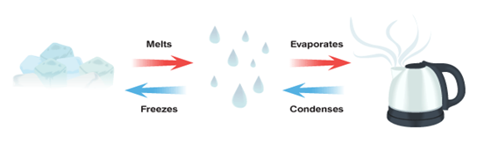  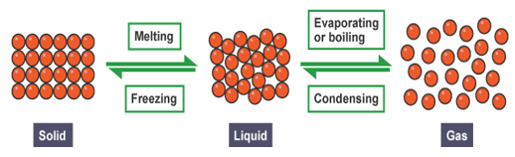
Key facts / information
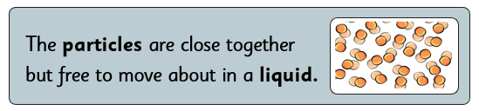
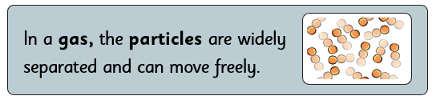
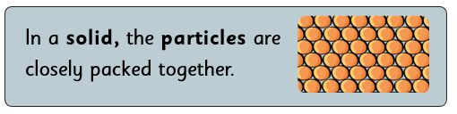
\
 | Key facts / information – separating materials
 | 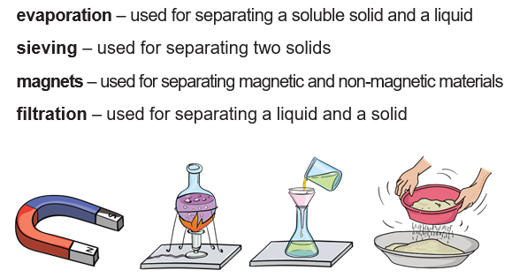
Key vocabulary
Conductor – A material or device which allows heat or electricity to pass through it
Dissolve – When something solid mixes with a liquid and becomes part of the liquid
Evaporation – The process of turning from liquid to vapour (gas)
Flexible – Capable of bending easily without breaking
Gas – An air-like substance which expands freely to fill any space available
Insulator – A substance which does not allow heat, sound or electricity to pass through it
Irreversible – Cannot be changed back to its original state
Liquid – A substance that can be poured, flows freely and will change shape dependiong upon the container it is in
Magnetic – A material that is attracted to a magnet
Material – The matter from which a thing is made from
Opaque – Not able to be seen through, not transparent
Property – The characteristics of something
Reversible – Able to be changed back to its original state
Solid – Firm and stable in shape, not a liquid or fluid. Can be cut, bent or squashed to change its shape
Soluble – Able to be dissolved, especially in water
Thermal – Relating to heat
Transparent – Allows light to pass through so that objects behind can be seen
 | Key knowledge: What I should know by the end of the unit?
- Compare and group together everyday materials on the basis of their properties, including their hardness, solubility, transparency, conductivity (electrical and thermal) and response to magnets
- Know that some materials will dissolve in liquid to form a solution and describe how to recover a substance from a solution
- Use knowledge of solids, liquids and gases to decide how mixtures might be separated, including through filtering, sieving and evaporating
- Give reasons, based on evidence from comparative and fair tests, for the particular uses of everyday materials, including metals, wood and plastic
- Demonstrate that dissolving, mixing and changes of state are reversible changes
- Explain that some changes result in the formation of new materials and that this kind of change is not usually reversible, including changes associate with burning and the action of acid on bicarbonate of soda.

Materials mini – quiz

- Solids, liquids and gases have different properties. Put a tick in the correct boxes.

 | Solid | Liquid | Gas
can fill the container
can change volume
can be cut

- Choose a suitable word to describe each of these materials:

- brick -

- glass -

- plastic -

- Name a reversible change.

- Name an irreversible change.

- Explain which method you would use to separate the following mixtures:

- sugar and coffee

- paper clips and rice

- sand and water

- What happens when…

- a liquid is heated?

- a liquid is cooled?

