Boarshaw Primary School – Science
Topic: Plants |  |  |  |  | Year 2
What should I already know? |  | Key Knowledge |  | Vocabulary
- Plants are living things.  - There are different types of plant.  - Plants have different parts.  - Some trees lose their leaves over Winter, others do not.  - Some plants produce flowers. |  | Parts of a plant  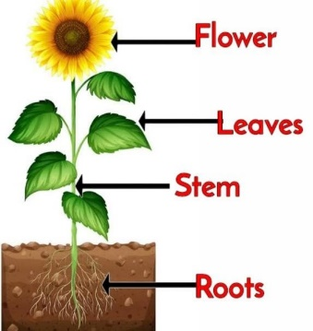  Plant lifecycle.  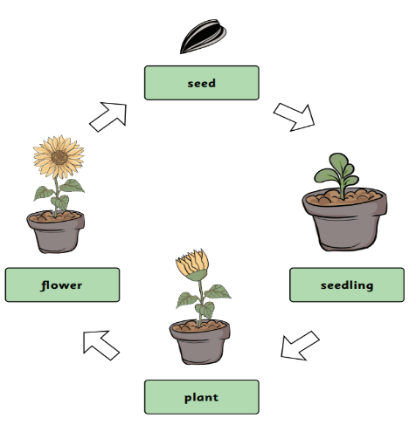  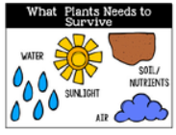 |  | Reproduce- Create another ‘baby’ the same as the parent  Germinate- A seed begins to grow  Nutrients- Something in food or water that is needed to stay healthy  Root- The part of the plant which keeps it in the ground and takes up water and nutrients from the soil  Stem- The part of the plant which supports the leaves and flowers  Seedling- A baby plant as it grows rom the seed  Observe- Look carefully and notice things  Record- Clearly show observations or findings for others to see  Table- A way to organise information in columns to make it clear  Examine- Look really closely at
Key Knowledge

Plants move, take in and give out gases, are sensitive, grow, reproduce, get rid of waste and consume nutrients.
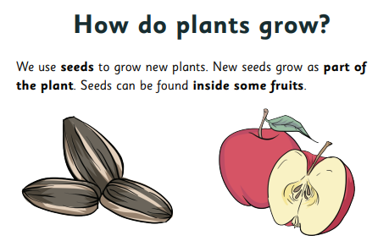

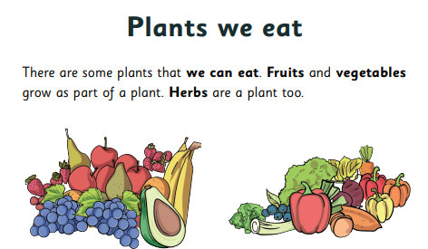
Boarshaw Primary School – Science
Topic: Plants |  |  | Year 2
 | End of Unit
Question 1:  Which three living processes do plants do?  a) Move  b) Grow  c) Walk  d) Reproduce  e) Don’t know |  |  |  | Question 4:  Which three things does a plant need to grow well?  a) Water, exercise, wind  b) Soil, water, wind  c) Soil, sunlight, water  d) Water, darkness, soil  e) Don’t know
Question 2:  What is happening in this picture?  a) The plant has fallen over  b) The plant is growing towards the light  c) The roots are not strong enough to keep the plant straight  d) The flower is trying to look out of the window  e) Don’t know |  |  |  | Question 5:  Name three different plants we can eat:
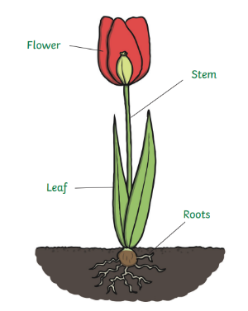  Question 3:  What is the missing label?  a) Bulb  b) Roots  c) Seed  d) Stalk  e) Don’t know |  |  |  | Question 6: Label the sunflower lifecycle  