**Boarshaw Primary School**



**Spring Term 2 Topic Unit Pack**

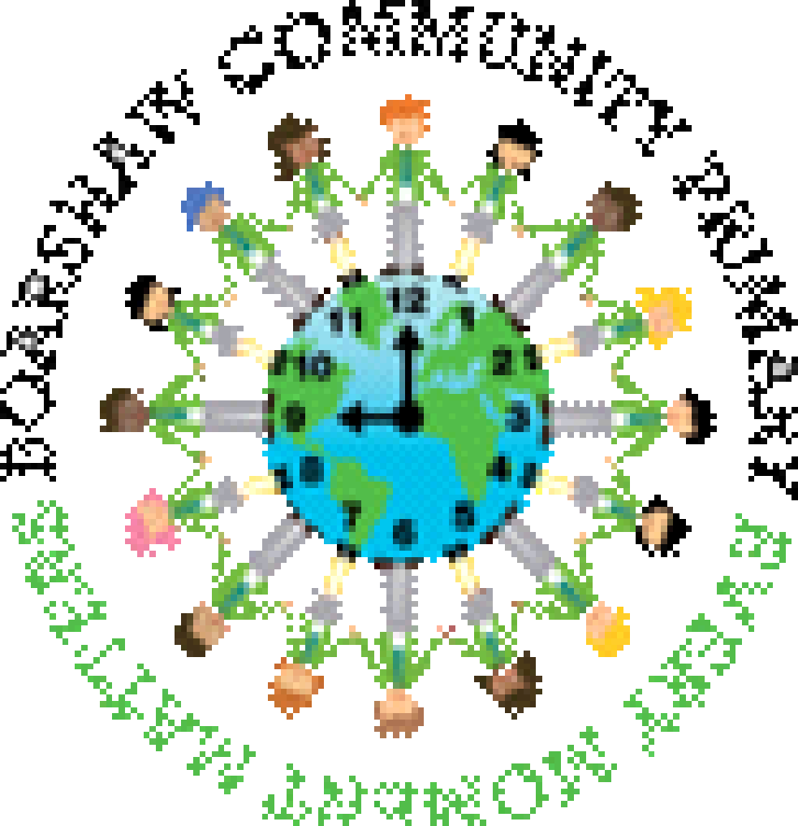

|  |  |
| --- | --- |
| TRANSPORT ACTIVITY TOPIC - CHILDMINDING PLANNING - IN HOME CHILDCARE  PAPERWORK - EYFS TOPIC - YouTube | **How do I get about and how do things move?**  Children will explore forces and how things move. They will compare how they move and how animals move. They will explore how toys move and what makes them work, including understanding the use of electricity and wind-up mechanisms. They will think about the different modes of transport they use. They will explore which transport we would use for different things. They will explore how we would travel to a different country. |

|  |  |
| --- | --- |
| TRANSPORT ACTIVITY TOPIC - CHILDMINDING PLANNING - IN HOME CHILDCARE  PAPERWORK - EYFS TOPIC - YouTube | What happened long ago? |
| Essential Knowledge |
| **By the end of this unit our pupils will know…** |
| * What kinds of transport there are and which ones we use for different jobs * How different things are powered, such as through electricity, by being pushed, pulled or wound up * How different things move in different ways, for example the different ways that animals move (swimming, flying, running, jumping) and the different ways vehicles move (flying, driving on two or four wheels) |

|  |  |  |  |  |  |  |
| --- | --- | --- | --- | --- | --- | --- |
| Launch |  | Explore |  | Celebrate |  | Vocabulary |
| Investigate a range of toys that move in different ways, such as pull along, wind up and battery operated toys |  | Investigate the types of transport around us and how they work. Make our own vehicles using a range of techniques and materials and use our bodies to explore different ways humans and animals move. Learn a transport song to perform. |  | Perform and record our transport song. Build a range of large vehicles outside using blocks and other resources and tell our friends in Reception all about them. |  | transport, vehicle, electricity, power, forces, movement, wheels, axles, construction, mechanic, engineer |

EYFS Curriculum Objectives

|  |  |  |  |  |  |  |  |
| --- | --- | --- | --- | --- | --- | --- | --- |
|  | Communication and Language | Personal, Social and Emotional Development | Physical Development | Literacy | Mathematics | Understanding the World | Expressive Arts and Design |
| Curriculum Coverage | To sing along to familiar songs  To learn about and talk about modes of transportation  To be able to identify and name the different types of vehicles they see on the road  To listen to stories and retain key vocabulary  To be able to talk about the setting, characters and the structure of a story (beginning, middle, end)  To be able to use familiar story phrases e.g. Once upon a time  To listen to and follow simple instructions and respond to questions appropriately  To talk in short sentences that others can understand  To be able to answer questions related to a story  To start conversations with others  To ask and answer ‘why’ questions | Coram SCARF unit: Rights and Responsibilities  To show independence in accessing and exploring the environment  To independently put on coats and use the toilet  To listen to and follow rules  To learn to look after resources within the classroom  To be aware of the different areas in nursery and how to explore them safely  To approach an adult if they need support  To begin to solve conflicts with peers with some adult support | To hold a pencil with a tripod grip when shown  To begin to form pre-writing shapes  To look at books independently, turning pages one at a time  To use balancing apparatus  To mark make using a comfortable grip when using pencils and pens  To know how to use one handed tools effectively  To be able to follow a simple sequence of movements to music and rhythm  To be able to fill containers with different materials, e.g. sand, water, and to show confidence in carrying them from one point to another without dropping them  To know how to use the outdoor climbing frame and the bikes/scooters to move in different ways | To be able to mark make and give meaning to their marks  To identify the pictures linked to sounds taught  To begin to form some letters correctly e.g. letters in their name  To be able to talk about their marks with confidence  To talk about the sounds they have identified  To join in with repetition within stories  To be able to talk about different parts of stories | To sing number rhymes and number songs  To recite numbers to 10  To subitise numbers 1 and 2  To count objects to 5 and begin to match to the correct numeral  To understand numbers can be ordered  To solve mathematical problems with numbers to 5  To describe a familiar route  To extend and create a repeating pattern | To learn about different modes of transportation and who operates them, how they travel to school, the local area and the natural environment  To know similarities and differences between different modes of transport  To explore how different toys and vehicles move  To talk about how things work  To know when to use different modes of transport  To understand the ecological impact of our transport decisions  To explore modes of transport in different cultures  To learn about Easter and understand how people celebrate Easter | To learn about different textures and talk about them. Feely bag activities with different objects for children to feel and describe  To engage in role play by making stick puppets of different story characters  Sing familiar nursery rhymes using correct words that have been learned  To realise tools can be used for a purpose  To create closed shapes with continuous lines which represent objects that can be spoken about or identified  To know about the different materials and what can be created with them  To know how to create recognisable representations of objects |

|  |  |  |  |  |  |  |  |  |  |  |
| --- | --- | --- | --- | --- | --- | --- | --- | --- | --- | --- |
| Week/Topic Question | Communication Language and Literacy | Maths | EAD | Topic Lesson 1 | Topic Lesson 2 | Topic Lesson 3 | *Topic Focus Task* | Physical Development | PSHE/C | ICT/Music  Song of the term – We All Go Travelling By (Barefoot Books) |
| Week 1- 28/2/2022  What kinds of transport are there?  3/3/22 – World book day | *Nursery rhyme of the week: The Wheels on the Bus*  Book: The Journey Home From Grandpa’s  Read the story and identify different modes of transport  Describe different types of transport  What are different modes of transport for? E.g. moving people, moving things, building, fun  Sing along to the song | *Number song of the week: Five Little Ducks*  Starter – Recite numbers to 10 forwards. Subitise numbers 1 and 2  Learning –  Numberblocks 5  Order groups of objects from smallest to largest number (0-5)  Order groups of objects and match numerals (0-5)  Order numerals (0-5) with visual cues  *FA: Ordering groups of objects and numerals* | Design and Technology:  What kinds of transport can fly? Make and test our own paper aeroplanes. | How do we get around? Name modes of transport in our everyday lives for transporting people. Walking, cycling, scooters, prams, motorbikes, cars, buses, trams, trains, planes. | Name vehicles used in construction. Cranes, diggers, bulldozers, cement mixers, forklift, tractor, dump truck etc. | Name vehicles used to transport cargo, e.g. vans, lorries, freight trains, ferries, etc. | *Sort vehicles and describe similarities and differences – appearance, movement, purpose etc.* | Fine motor focus – Folding paper (making aeroplanes)  Gross motor focus – Filling and carrying containers | **Looking after myself**  Healthy eating. Talk about healthy food. Look at sugar and why sugar is bad for you. | ICT – BeeBots  Music – Listen to song We All Go Travelling By and begin to learn the repeated lyrics |
| Week 2-  7/3/2022  How are things powered? What makes things move? | *Nursery rhyme of the week: Baa Baa Black Sheep*  Book: You Can’t Take an Elephant on the Bus  Focus on vocabulary of movement  *FA: Answering why questions – why can’t an elephant go on the bus? Etc.* | *Number song of the week: 1, 2, 3, 4, 5, Once I Caught a Fish Alive*  Starter – Recite numbers to 10 forwards. Subitise 1 and 2.  Learning –  Numberblocks – How to Count  Solve mathematical problems with numbers to 5 – adding with objects. Doubling. | Will it slide? Provide ramps with different materials on. Allow children to experiment with sliding different objects down the ramps. Which materials are the slipperiest? Which objects slide best?  Leave out ramps for children to experiment with in CP. | Explore forces we can exert with our bodies. Push, pull, lift, drop, roll different objects and describe the movements we create. | Explore different moving toys – wind up, pull back and let go, pull along, electric moving toys (battery powered). | Learn about different ways vehicles etc move – electricity, steam power, gliding, paddles, wind power e.g. sailboats, etc. | *Sort vehicles and describe similarities and differences – appearance, movement, purpose etc.* | Fine motor focus – Writing letters from names – using formation models  Gross motor focus – Building vehicles using large blocks | **Looking after myself**  Washing our hands. Why do we need to do this? Why do we need to clean our teeth? Explore the reasons. | ICT – Internet safety – DigiDuck  Music – Practise singing song |
| Week 3-  14/3/2022  Science Week – growing  How do plants grow? Why are plants important? | *Nursery rhyme of the week:* *London Bridge is Falling Down*  Book: Oliver’s Vegetables  Book talk and reading the story  Sequence the story  Role play the story using masks and vegetables  Feely bag of vegetables – how does it feel, how does it smell, what do you think it is, what does it look like?  Draw and colour our favourite vegetables | *Number song of the week: One Potato, Two Potato*  Starter – Recite numbers to 10 backwards. Order numbers to 5  Learning –  Numberblocks – The Whole of Me  Exploring the composition of numbers to 5 and partitioning  Counting and matching to correct numerals   * Recognise numerals * Counting objects and knowing the final number counted is the total   *FA: Explore making 5 with part part whole models and five frames* | Make salt dough with the children and use it to make different vegetables | How do plants grow? What do they need to grow? | What kinds of plants are there? Plants we eat – fruits and vegetables, decorative plants, trees | Why are plants important? Talk about the importance of plants in our diet, importance for animals and for our planet | *Plant sunflower seeds and talk about what they will need to grow. Make predictions as to what we think will happen first, next, then.* | Fine motor focus – dough disco tray – picking peas  Gross motor focus – making and following roads and road furniture using outdoor resources | **Looking after my environment**  Discuss environmental factors, e.g. recycling, leaving electricity on, litter pollution, use of transport. How can we look after the planet? | ICT – Digiduck internet safety  Music – Practise singing song |
| Week 4-  21/3/2022  How do vehicles move?  Which vehicles do we use for which purposes? How do we get to other countries?  Mothers day | *Nursery rhyme of the week:*  *Mothers Day*  Book: Naughty Bus  Tell children the title and ask them what they think might happen. Why is the bus naughty? What will it do?  Read story.  Create a class book – Naughty Car/Scooter/Helicopter etc. Children suggest settings for our naughty vehicle to explore and work together to create pages for our book. | *Number song of the week: One, Two, Buckle My Shoe*  Starter – Recite numbers to 10 backwards. Count and match numerals  Learning –  Numberblocks –  Holes  The Terrible Twos  Solve mathematical problems with numbers to 5 – subtracting with objects. Doubling and halving. | Create junk modelling vehicles together in groups. (Each group makes a different vehicle) Talk about the vehicle parts – wheels, wings, rotors etc – what they are for and what they look like, what materials we could use to represent them in our models. | How do vehicles move? What are the different parts of vehicles that create different types of movement? How do wheels work? | What are different vehicles for? How are they suited to their purposes? | What vehicles do we use to get to other countries? Would a bike be suitable for long journeys? Would you use an aeroplane to go to the park? | *Plant sunflower seeds and talk about what they will need to grow. Make predictions as to what we think will happen first, next, then.* | Fine motor focus – Tracing shapes and lines with mark making tools  Gross motor focus – musical statues, holding poses | **Looking after my environment**  Leave the classroom a mess. What has happened? Why do we need to take care of our environment? | ICT – Use simple programmes to create pictures and complete games e.g. jigsaw puzzles  Music – Practise singing song and accompany with actions |
| Week 5-  28/3/2022  How do we move? How do animals move? | *Nursery rhyme of the week: The Grand Old Duke of York*  The Enormous Turnip  Talk about setting, characters. Record children’s speech and vocabulary  Story sequencing – talking about the beginning, middle, end of the story  Story sequencing – story maps  Retelling the story using a range of resources – story telling tray, puppets, masks etc. | *Number song of the week: One, Two, Buckle My Shoe*  Starter – Recite numbers to 10 forwards and backwards. Count and match numerals  Learning - Describe a familiar route. Set up Goldilocks path through the woods for children to follow and describe. Show and talk about simple maps. Concepts of left and right turns, forwards and backwards | Dancing – introduce different body parts and how we can move them to create a dance. Work in groups to practise some dance moves using different body parts | How do people move? What do our body parts do to help us move? | How do animals move? Do animals move like us? Running, jumping etc. | What special ways of moving do animals have? Flying, swimming underwater, climbing, gliding etc. | *Follow simple sequences of actions* | Fine motor focus – forming prewriting shapes – tracing sheets and templates  Gross motor focus – Using balancing apparatus | **Looking after others**  How do we help at home? Who do we help? Different scenarios of how they could help and what they could do. | ICT – Use simple programmes to create pictures and complete games e.g. jigsaw puzzles  Music – Practise singing song and accompany with actions |
| Week 6-  4/4/2022  Easter  Spring | *Nursery rhyme of the week: Sing a Song of Sixpence*  The Easter Story | *Number song of the week: (Twinkl) Five Easter Eggs*  Starter – Recite numbers to 10 forwards and backwards.  Learning – Recap number – watch Numberblocks Hide and Seek  Extend and create repeating patterns – spring and Easter objects | Create a dance in groups – adult helps children pick some dance moves using different body parts and put them together. Perform to the class. | What is Spring? When does Spring begin? | How can we tell it’s Spring time? What happens to the weather and environment in Spring? | Look at animals in Spring time. Learn about baby animals. | *Create Easter Story / Spring time crafts.* | Fine motor focus – Cutting skills  Gross motor focus – Using climbing frame and bikes/scooters to move in different ways | **Looking after others**  Show pictures of our friends on the board. How could we help our friends? How can we be kind? | ICT – Take and retrieve photos  Music – Perform and record song |

Termly Baking Experience – Gingerbread Men