Celebrating Cultures & World Book Day
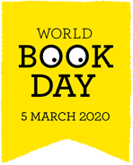
17th February 2020

Dear Parent/Carers,

On Thursday 5th March it is World Book Day. Children can come dressed as their favourite book character on this day. There will be prizes for the best costumes. Attached is also information about a competition for Book in a Jar. Entries can be sent into school up to 5th March and a winner will be selected on that day. Parents are also invited in from 2:30pm to read with their child/children. Children will engage in a range of activities throughout the day linked to books and reading. Our theme this year is going to be linked to books from different cultures as we will be celebrating our diverse cultures throughout the week beginning Monday 2nd March.

As part of our Celebrating Cultures week, we would like to invite parents into school on Wednesday 4th March from 2:00pm for a cultural afternoon. We are asking for parents to bring a plate of food to share their local cuisine with parents and children. If you are able to bring a plate of food, please could you sign and return the reply slip below so that we can cater accordingly.

We hope to see you on the above afternoons.

Thank you,

Mrs Thackway
English Coordinator

Name of child/children _________________________________

I would like to attend the Cultural afternoon on Wednesday 4th March

I am able to provide a plate of food

Book in a jar competition
We are running a ‘Book in a jar’ competition to celebrate World Book Day. Children are invited to think about how a favourite book could be represented in a simple jar.
There are some examples below for you to have a look at. Any clear jar can be used, a coffee jar, jam jar or other. You can put carefully chosen items to represent your book into your jar, selected quotes from your book, perhaps even clues about its characters or setting.
Please make sure that any ‘Book in a jar’ competition entries are clearly labelled with the book that is being represented, your child’s full name and year group.
All entries must be in school on the morning of Thursday 5th March for judging. Winners will be announced on that day and the jars will be available for viewing in the school library as part of our World Book Day celebrations.
Good luck!
Mrs Thackway

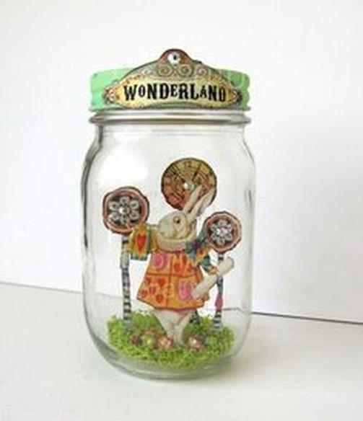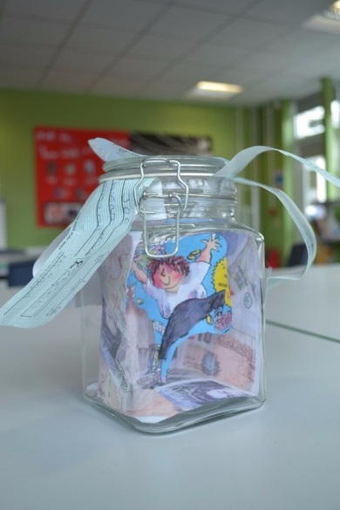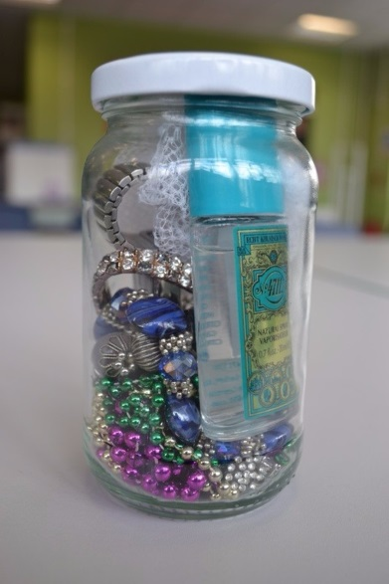
Alice in Wonderland Billionaire Boy Gangster Granny

