Boarshaw Primary School – Geography
Topic: Where would you prefer to live, England or Kenya? |  | Strand: Place Knowledge &  Human and Physical Geography |  | Year 2
What should I already know? |  | Countries on a world map. |  | Vocabulary
- The names of the four countries and capital cities of the UK.  - The geography of our school and the key human and physical features of Manchester.  - Where to find the hot and cold places of our world in relation to the North and South Poles and the Equator.  - That the weather and weather patterns in the UK are seasonal. |  | 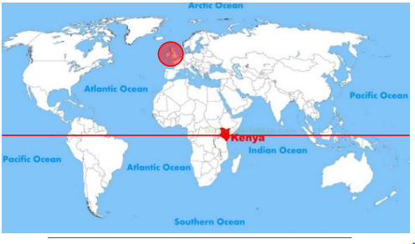  Equator |  | capital city the city where the government sits  city a large town, like Manchester  climate weather that is typical of a place  continent a very large area of land that consists of many countries link Europe  country an area of land that is controlled by its own government  drought very little rain and there is no water  humid a climate that is very hot and damp  landscape everything you can see when you look across an area of land including hills, rivers, buildings, trees and plants  National Park A national park is a protected area of land where only tourism and research is allowed by humans. No humans live in national parks  Savannah A grassy plain with few trees  town a large group of houses, shops and buildings where people live and work. Towns are larger than villages but smaller than cities.  vegetation plants, trees and flowers  village a small group of houses, perhaps with a few shops  weather the condition of the atmosphere at a given time
Key Knowledge |  | Key features of Kenya and England.
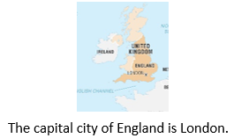  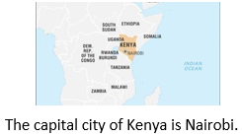  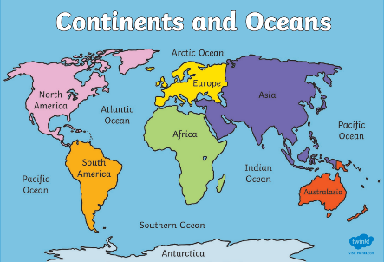 |  | Kenya England  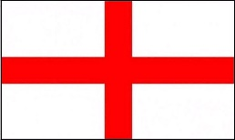  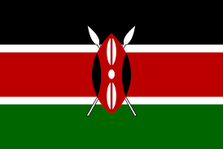  English flag  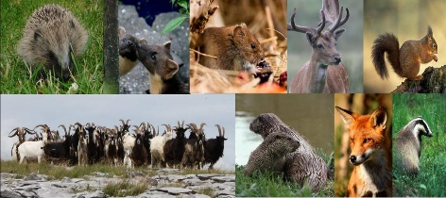  English animals  Kenyan flag  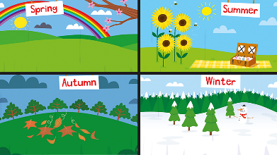  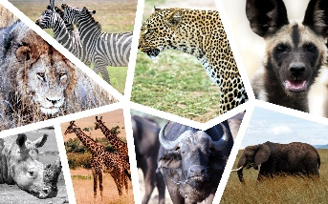  4 Seasons- Spring, Summer, Autumn and Winter.  Kenyan animals  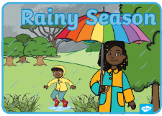  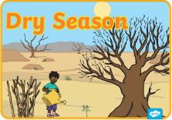  2 Seasons- dry and rainy.

Boarshaw Primary School – Geography Year 2
Topic: Where would you prefer to live, England or Kenya? |  | Year 2
End of unit assessment.
Question 1:  What are Kenya and the UK?  a) Continents  b) Countries  c) Towns  d) Cities  e) Don’t know |  |  | Question 4:  How are Manchester and Kenya similar?  a) They both have hills  b) They both have a beach  c) They both have a national park  d) They both have slum areas  e) Don’t know
Question 2:  What are Africa and Europe?  a) Continents  b) Countries  c) Towns  d) Cities  e) Don’t know |  |  | Question 5:  Which of these statements are false? (circle 2)  a) Manchester is a coastal city  b) Kenya has over 50 national parks  c) There are many museums in Manchester  d) Kenya is made up of several islands joined together  e) Don’t know
Question 3:  Which of these can I use to find where the UK and Kenya are? (circle 2)  a) A telescope  b) An atlas  c) A dictionary  d) An information book  e) Don’t know |  |  | Question 6:  How are Manchester and Kenya different? (circle 2)  a) Kenya is a city and Manchester is a village  b) Kenya has a national park and Manchester does not  c) Kenya has rhinos and lions but Manchester does not  d) Manchester is by the sea and Kenya is not  e) Don’t know

