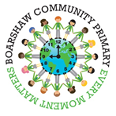

## **Weekly Timetable**

**Monday** – New spellings set for the week

**Tuesday-** Penguins PE Day

**Wednesday** – Penguins and Lobsters PE Day

**Thursday** – Lobsters PE Day

**Friday** – Spelling test in school

**Please sign and return your child’s reading book and record on a daily basis.**

**Our learning challenge this half term!**

**Where would you prefer to live, England or Kenya?**

As part of this Geography unit we will be developing our map skills. We will be able to name and locate continents and oceans on a map and make comparisons between countries.

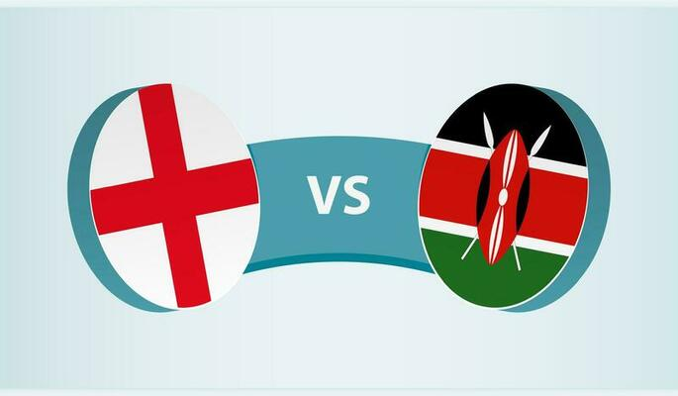

Dear Parents and Carers,

A warm welcome back to school! We hope you have had a well-deserved rest over the half term.

This term it is important to read with your child and help them learn their spellings every night. Once they have read please record this in your child’s reading record.

Every Monday your child will receive continue to receive homework. Please make sure you are completing the spellings set on Spelling Shed and encouraging your child to have a go on Numbots. We give out Numbots certificates every Friday during celebration assembly. If you cannot access homework online please get in touch with your class teacher who will provide paper copies for you. We encourage parents to support their children with their homework each evening. Spelling Tests take place each Friday in school.

Please make sure you provide your child with the correct uniform for PE. Black shorts,

pumps and a white t-shirt. A black jumper and tracksuits may be needed for outdoor PE.

Children are not allowed to wear any jewellery in PE so please make sure your child

removes any jewellery on the mornings of PE days unless they can remove them

themselves. Children with long hair must have it tied back.

Kind regards,

Miss Plant (Penguins) and Mrs Greenhalgh (Lobsters).

|  |  |
| --- | --- |
| **Our learning this half term!** | |
| **English:** | Common and proper nouns.  Verbs  Subjects and pronouns. |
| **Maths:** | Addition and subtraction  2D and 3D shapes |
| **Reading:** | Window – Jeannie Baker |
| **Geography:** | Where would you prefer to live, England or Kenya? |
| **Science:** | Living things and their habitats. |
| **Computing:** | Coding. |
| **Art:** | Drawing |
| **RE:** | What do candles mean to people? |
| **PSHE:** | Valuing differences. |
| **Music:** | Ho, Ho, Ho. |

**Year 2 - Class Newsletter**

**Autumn 1**