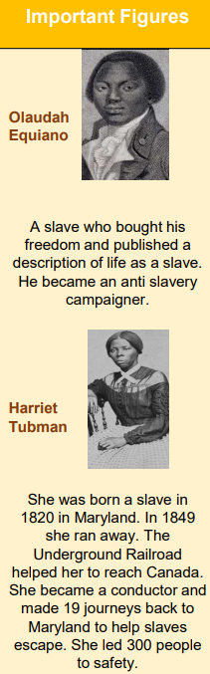

What was the slave trade and what was Britain’s role in it?

What were slave auctions and what would it feel like to be a slave?

What was life like on board the transportation ships?

How did the slave trade end?

A chronological knowledge of local, British and world history.

Be able to contrast and compare trends over time.

Devise historically valid questions and construct informed arguments from historical resources.

**What will I know by the end of the unit?**

**What should I already know?**

