Reviewed on: | September 22
Next review: | September 23
Staff Responsibility: | A Facchin
Linked policies: | Safeguarding, children missing in education
Signed by chair: | L Vitler
Date: | September 21

Attendance and Punctuality Policy
2022-23

As a school we have a duty, by law, to –
- Promote good attendance and reduce absence, including persistent absence;
- Ensure every pupil has access to full-time education to which they are entitled; and,
- Act early to address patterns of absence.
- Encourage all pupils to be punctual to their lessons
- Ensure all parents perform their legal duty by ensuring their children of compulsory school age who are registered at school attend regularly.
School Attendance: Statutory guidance and departmental advice, DFE Oct 2014

Boarshaw Community Primary School expects the highest attendance and punctuality from all pupils, at all times.
We support pupils and their families to ensure that excellent attendance is achieved.
- At Boarshaw, we are continuously working towards our goal of 100% attendance for all pupils.

- Overall Aims:
- To ensure that every child is safeguarded and their right to education is protected.
- To ensure the school attendance target is achieved, through rewards and incentives for good attendance and punctuality.
- To raise standards and ensure every child reaches their full educational potential, through a high level of school attendance and punctuality.
- To ensure all the stakeholders, governors, parents, pupils and staff receive regular communication, about the importance of good attendance and punctuality.
- To keep accurate, up-to-date records and have a robust and rigorous system for analysing attendance.
- To identify causes of low attendance/punctuality with individuals, classes and groups of pupils and address them.
- To work with external agencies, in order to address barriers to attendance and overcome them.

- Rights and responsibilities for attendance/punctuality:
The Legal Framework:
There are legal obligations on:
- The parent(s) to secure education for their children, whether at school or otherwise, to send them to school regularly once they are on the register
- The School to register attendance and notify the Local Authority of absence from school
- The Local Authority to provide education and to enforce attendance.
Head Teacher:
- To be responsible for the overall management and implementation of the policy.
- To deal with parental requests for extended leave in line with Rochdale Local Authority policies and procedures.
- To consider the use of Penalty Notices, in line with Rochdale Local Authority policies and procedures.
Deputy Head Teacher:
- To lead on/take responsibility for attendance/punctuality, on a day-to-day basis, including liaising with/responding to parental enquires.
- To oversee the analysis of/analyse weekly/termly/yearly data and respond to findings.
- To meet with the School Administration staff to monitor the systems and structures, ensuring they are having an impact on pupil attendance and punctuality.
- To liaise with external agencies such as the Education Welfare Officer and make referrals where necessary.
- To ensure that rewards and incentives for attendance and punctuality are being used.
- Work with the teachers, to plan for the reintegration of pupils after long-term absence.
- To revise and amend the policy, as required.
School administration staff:
- To carry out and record the outcome of first response calls, when a child doesn’t arrive at school when no reason has been received.
- To monitor weekly attendance data for year groups.
- To check the school answer phone and take messages from parents/carers about pupil absence.
- To promptly inform the DHT, if there are any concerns relating to attendance/punctuality
- To support the DHT in producing weekly/termly/yearly data for SLT to analyse.
- To record reasons for absence and updating class registers.
- To implement the daily checking of SIMS registers after the morning and afternoon registration sessions.
- To contact parents/carers by letter, following 3 instances of lateness or absence.
- To maintain SIMS attendance records in line with this policy.
- To liaise with and report to with outside agencies such as the Education Welfare Service.
- To report to the Local Authority, as requested.
- To oversee the admission and induction of new pupils.
- To support DHT with the promotion good attendance and punctuality.
- To ensure staff are following the registration systems and structures in this policy.
- Inform parents of school procedures, when parents have failed to inform the school.

Staff:
- To ensure quality first teaching every day; with lessons that are well planned and resourced so that they challenge, inspire and meet their learners’ needs.
- To keep accurate and up-to-date daily records of pupil attendance through the SIMS register system.
- Take a formal register of all pupils twice a day. This is done on the school’s SIMS system at 9.00 am and 1.00 pm.
- To regularly remind children and parents about the importance of good attendance.
- To follow up on pupil absence by ensuring reasons for absence are sought.
- Provide a welcoming and safe environment, which encourages attendance and promotes the best performance from children.
- Establish good and effective communication links with parents/carers and work collaboratively in meeting the child’s needs.
- If required, to work collaboratively with other agencies to assist them in fulfilling their statutory duties, regarding for example, child protection
- Work with pupils and their families where attendance is a concern, identifying barriers to good attendance and working to overcome these.
- To promptly inform the DHT, of pupils who persist with poor attendance.
- To feed back to parents about pupil attendance and punctuality regularly and at Parents Evenings and via Assertive Mentoring target sheets.
Safeguarding:
- Child protection and safeguarding concerns must be acted on immediately in line with the schools Child Protection and Safeguarding Policy

Parents:
Children should only be kept at home if they have a serious illness or injury. If this is the case, parents should contact the school first thing. If a child has a minor illness e.g. mild headache, stomach aches etc. parents should inform the school and bring them in. If they don’t get any better, school will contact parents straight away, to collect them. If pupils’ have a dental, clinic or hospital appointment, parents should let the school know. Where possible, these should be made outside of school times. Pupils’ should be brought child back to school after appointments. Pupils should miss as little time as possible. Parents are expected to provide evidence of medical appointments and evidence of illness that has meant the child has had time off school.
Therefore, parents are expected to:
- Ensure their child attends school and arrives on time every day.
- Promote a good attitude to learning by ensuring their children attend school in the correct uniform and with the basic equipment required for lessons.
- Not arrange medical and dental appointments in school time wherever possible.
- Telephone to inform the school to on the first day of absence for their child.
- Provide a written explanation of absence, including dates of absence as soon as their child returns to school.
- Work in partnership with the school and other agencies in the best interests of their child; this includes informing the school about significant influences and changes in the child’s life, which may impact on learning.
The Local Authority, through the Educational Welfare Service, is expected to:
- Support the school in improving attendance, through whole school initiatives and individual pupil interventions.
- Work with families and other agencies to remove barriers to good attendance.
- Ensure that parents are informed of their responsibilities in relation to attendance.
- Uphold and enforce the law in respect of attendance, child employment, and Strategies for promoting/rewarding excellent attendance:

- The school action plan: see appendices 1, 2 and 3 for more details
Aims:
- To ensure good attendance and punctuality is regularly promoted and supported and remains high profile across school.
- To achieve high levels of attendance and punctuality through rewarding good attendance and punctuality.
- To target individual pupils and their families to ensure improvements are made.
Weekly Celebration Assemblies
Celebration Assemblies are held every week in Key Stages. Pupils are informed on a weekly basis of attendance achievements. The class achieving the highest attendance, receive the attendance prize. The winning classes also gets a star on their class attendance chart, the class with the most stars at the end of term gets a treat afternoon.
This develops healthy competition between year groups to improve attendance. It also engages the form teacher in conversation with their classes about attendance.
School Newsletter and website
Each week, the school newsletter is used to highlight the importance of good attendance and punctuality. It regularly includes sections reminding parents of our school attendance target and what that means in terms of number of days absent. It also includes information about any initiatives, which the school is using, to promote attendance and punctuality. This information is also included on the school website and via twitter.
School Attendance Board
The board includes attendance information and information about the classes with the highest attendance and punctuality. Details of how parents can support the school by improving their child’s attendance and punctuality, is also included.
Breakfast Club
Breakfast club runs every day and is free for targeted pupils. This supports parents by allowing them to drop their children off from 8.00 am, ensuring they are on time for school.
The School Learning Environment
A welcoming, organised learning environment, that supports and celebrates its learners is a key factor in ensuring children enjoy school and attend regularly. All staff ensure that their learning environments are of a high quality. Regular, rigorous environmental audits are carried out by the SLT, to ensure this.

Staff Promoting Good Attendance
It is important that teachers are regularly promoting good attendance with their classes. Good class attendance is attributed to good teaching and this is celebrated.
Parent/teacher consultation evenings
This provides an opportunity for form teachers to praise and recognise excellent attendance or share attendance concerns and discuss barriers to good attendance. Where necessary a target for improving attendance is set. The class teacher then monitors this. If there is no improvement in attendance/punctuality, the pupil is referred to the DHT.

- Monitoring and Recording Attendance & Punctuality
Class Registers
Class registers are recorded using SIMS. The system ensures that no children are missed and that pupil information can be shared quickly and securely. Registers are the only way of recording pupil attendance and must be completed accurately. This is the responsibility of whichever member of staff has been directed to take the register for that session.
Morning Register
Class registers are to be taken at 9am. At that point, the teacher must submit their final register and close down SIMS.
From 9.00 am the school playground gates are closed. The school administration staff are responsible for children arriving late. The children’s names and classes are recorded in the late book. This is to ensure that no children are missed on the register due to arriving in school late.
Children arriving after 9:00am are recorded as ‘L’ (late) in the register.
Children arriving after 9.15am are recorded as a ‘U’ (arrival after registration closed).
The School Administrator officer then checks that the children who have arrived late have been marked in the registers and corrects any mistakes or inputs codes for children who are known to be absent. The administrator then begins first day absence calls.
Afternoon Register
Registers must be done at 1pm, by teaching staff straight after lunch before afternoon lessons commence.
School Attendance Letters
The school sends out letters, to communicate with parents about attendance and punctuality. (Copies of all standard letter formats are included at the end of this document.)
Monitoring First Day Absence
If a child is absent from school and the school has not received a phone call or other message from the parent/carer, a first day absence call will be made. The admin staff follows this system:
- Phone parents’ contact number(s).
- Repeat this during the first morning of absence if no response.
- Speak to the parents face-to-face or by phone the next day and establish reasons for absence and update contact numbers.
The parent/carer is asked to provide a reason as to why the child is not in school. The absence reason is recorded next to the child’s name on the first day absence sheet and this is filed in the absence folder.
The admin staff must establish a reason for every absence. No absence should be left on the system as an ‘N’ (no reason given) code. If the admin staff has not been able to contact parents after 2 days then the absence is recorded as ‘O’ (unauthorised).
Pupils who have been identified as vulnerable will be highlighted to the safeguarding team via CPOMS and verbally.
Attendance Meetings
The DHT monitors individuals, classes, year groups, different ethnic groups, SEN and FSM pupils. They identify patterns and trends in absence/punctuality, including persistent absence. The systems and structures are then followed, to improve attendance for these individuals or groups. Letters are sent out to parents whose children’s attendance is below 95% and parents are invited to work in partnership with the school.
Summary of procedures to promote good attendance/punctuality:
Extended Holidays/Holidays during term time:
In line with regulation, leave for pupils during term time is not authorised under any circumstances. The school recognises that taking children out of school may constitute a safeguarding risk and will make necessary enquiries, in order to be satisfied that the child is not at risk. The school may contact outside agencies in order to ensure that a visit is legitimate and safe for the child/children.
Head teachers may now only grant leave in term time where the circumstances are exceptional, for example:
- death of parent/carer or sibling of the pupil
- life threatening or critical illness of parent or sibling of the pupil
Family emergencies need careful consideration. It is not always in the best interest of the child, nor appropriate for them to miss school for family emergencies that are being dealt with by adult family members. Being at school, friendships and support from staff can provide children with stability and care during difficult times. The routine of school can provide a safe and familiar background during times of uncertainty.
If you have exceptional circumstances, which have led you to request leave in term time for your child/ren, please complete the required form, which you can obtain from the school office. The Head Teacher will then decide, on whether or not the leave can be lawfully authorised and will do so only if there is a genuine, exceptional and urgent reason for a child to be absent during term time.
Penalty Notices
If a child is taken out of school without the Head Teacher’s authorisation, it will be recorded as unauthorised absence. This may lead to the issuing of a penalty notice and legal action being taken.
Section 23(1) Anti-Social Behaviour Act 2007:
The issuing of a Penalty Notice is considered appropriate in the following circumstances:
- Overt truancy (including pupils caught on truancy sweeps)
- Parentally-condoned absences
- Unauthorised holidays in term-time
- Excessive/delayed return from agreed/authorised holidays without prior agreement from school.
- Persistent late arrival at school (after the register has officially closed)

This is not an exhaustive list. Each case will be considered individually
Types of penalty notices:
- Unauthorised Absences Penalty Notices are issued if a minimum of 20 sessions (10 school days) are lost to unauthorised absence by the pupil during the current term or within any 12 week period. It is good practice to issue a formal warning and/or to allow the parents a specified period, usually 15 school days, to effect an improvement.
- Penalty Notice for Unauthorised Leave during Term Time are issued if a pupil is absent for a minimum of 10 sessions (5 school days) for an absence relating to leave during the term time. Penalty Notice for Unauthorised Leave during Term Time will be issued without the issue of a warning if a pupil is absent for a period not agreed or authorised by the Head Teacher.
- Exclusions Penalty Notices are issued if a child of compulsory school age who is a registered pupil at a school and is excluded from that school, either for a fixed period or permanently; his/her parent/carer is guilty of an offence under Section 103 of the Education And Inspections Act 2006 if that child is present in a public place during school hours without reasonable justification during the first five days of each and every fixed period or permanent exclusion.

Section 444(1) Education Act 1996:
“If you are the parent of a child of compulsory school age who fails to attend school regularly, you are guilty of an offence.”
The court can fine each parent up to £1,000 per child, order payment of the prosecution costs and/or make a Parenting Order.
Please note that:
- penalties and prosecutions are in respect of each parent for each child.
- Parent’ includes any person who is not a parent of the child but who has parental responsibility for the child (and applies whether or not that person lives with the child) or who has care of him/her.
- These prosecutions are criminal proceedings and could result in you having a criminal record.

The following Appendices support this policy:
Appendix 1: School action plan
Appendix 2: Attendance procedures
Appendix 3: escalation of intervention
Appendix 4: absence in one school year

Appendix 1: School action plan
RED- these are children whose attendance falls below 80%. Immediate EWO involvement .Parents will be asked to attend a meeting. During the meeting we will outline the importance for good attendance and go through the previous year registration certificate.
Parents will receive a phone call on first day of absence.
These children will then be given weekly sticker/certificate for 100% attendance.
Over a term if their attendance is over 95% the child will receive a prize.
RED- these are children whose attendance falls between 80%-89%. Parents will be asked to attend a meeting. During the meeting we will outline the importance for good attendance and go through the attendance policy.
Parents will receive a phone call on first day of absence.
These children will then be given weekly sticker/certificate for 100% attendance.
Over a term if their attendance is over 95% the child will receive a prize.

AMBER-these are children whose attendance falls between 90%-92%. Parents will be asked to attend a meeting. During the meeting we will outline the importance for good attendance and go through attendance policy.
Parents will receive a phone call on first day of absence.
These children will then be given weekly sticker/certificate for 100% attendance.
Over a term if their attendance is over 95% the child will receive a prize.
AMBER-these are the children whose attendance falls between 93%-96%.
The parents of the child will be sent a letter to highlight their attendance and information about why it is vital they attend school.
Parents will receive a phone call on first day of absence.
If attendance does not improve they will be called in for a meeting.
These children will then be given weekly sticker/certificate for 100% attendance.
Over a term if their attendance is over 95% the child will receive a prize.
.

GREEN- these are the children whose attendance falls between 97%-99%
Certificate every term
GREEN- these are the children whose attendance is100%
Certificate and prize every term

At the end of each term, pupils will be given raffle tickets according to their attendance and punctuality figure -
Raffle tickets - 95%-97% 1 ticket, 98%-99% -2 tickets 100%- 3tickets
At the end of summer term, there will be three prizes to be won for the pupils who have raffle tickets.

Punctuality –
Children who are persistently late will be identified and the following course of action will apply –
Parents will be asked to come into school for a meeting. During the meeting we will outline expectations. Targets will then be set.
Parents will receive a phone call at 8.15am.
If children are in school on time they will receive a sticker that day.
These children will then be given weekly certificates for 100% punctuality
Over a half term if their punctuality is Boarshaw Brilliant the child will receive a prize.
Over a term if their punctuality is Boarshaw Brilliant the child will receive a prize.

Whole school incentives-
Weekly - winning classes in EYFS/KS1/KS2 receive attendance superhero, prize and star on class chart.
Termly –class with most stars receives a treat afternoon.
Yearly – winning class receives a treat day.

Appendix 2: Attendance procedures

Daily procedures | By whom | Outcomes / action
Parents ensure pupils arrive at school on time | Parents/carers
Parents inform the school by 9 am, if their child is absent that day | Parents/carers | Office/Support staff update registration codes
Pupils arriving late to school are registered at reception, by Admin staff | Admin | Absence mark on SIMS amended to a late mark by admin staff
Teachers record attendance using the schools SIMS system. This is done at 9am and 1pm.  Complete attendance/punctuality record for DHT – as required. Send to the office by 9.15 am | Teachers/Supply staff  Teacher/TA | Staff use a paper register, if required.  Teacher takes responsibility for promptly informing DHT/SA of concerns.
1st day absence phone calls are made to inform parents of their child’s unexplained absence for that day  DHT informed of attendance/punctuality | Admin staff  DHT | Admin staff updates attendance codes
Weekly procedures | By whom | Outcomes / action
Attendance/punctuality statistics produced by year group and school | Admin staff | Entered into Attendance Overview spread sheet to allow for monitoring and analysis
Attendance statistics produced and shared in Celebration Assembly, website and displayed on the School Attendance Boards | Admin Staff | Parents are able to see which class(es) have been successful with their attendance.
Absence codes for individual pupils are updated using SIMS to show reason for absence | Admin staff | Information provided here is used to provide targeted interventions as appropriate
Half termly and termly procedures | By whom | Outcomes / action
Analyse attendance/punctuality data to monitor trends and progress | Admin/DHT
Assemblies to promote attendance/punctuality and share term’s data and progress | Admin/DHT
Discussions as required in response to specific attendance/punctuality concerns of a particular cohort of pupils | HT/DHT
Individual attendance/punctuality discussed with pupils and families, at parents’ evenings | Class teachers | Mentoring and advice on attendance/  punctuality issues provided to all families
Analyse attendance/punctuality data and information to identify cases of concern and develop appropriate interventions | DHT | Targeted intervention for individual concerns
Meeting to discuss individual cases, monitor progress and refer new concerns. Support and meeting provided for pupils and families. | DHT/HT
Review success and impact of attendance/punctuality strategies for the term | DHT/Admin/HT | Amend and refine interventions as

Appendix 3: escalation of intervention
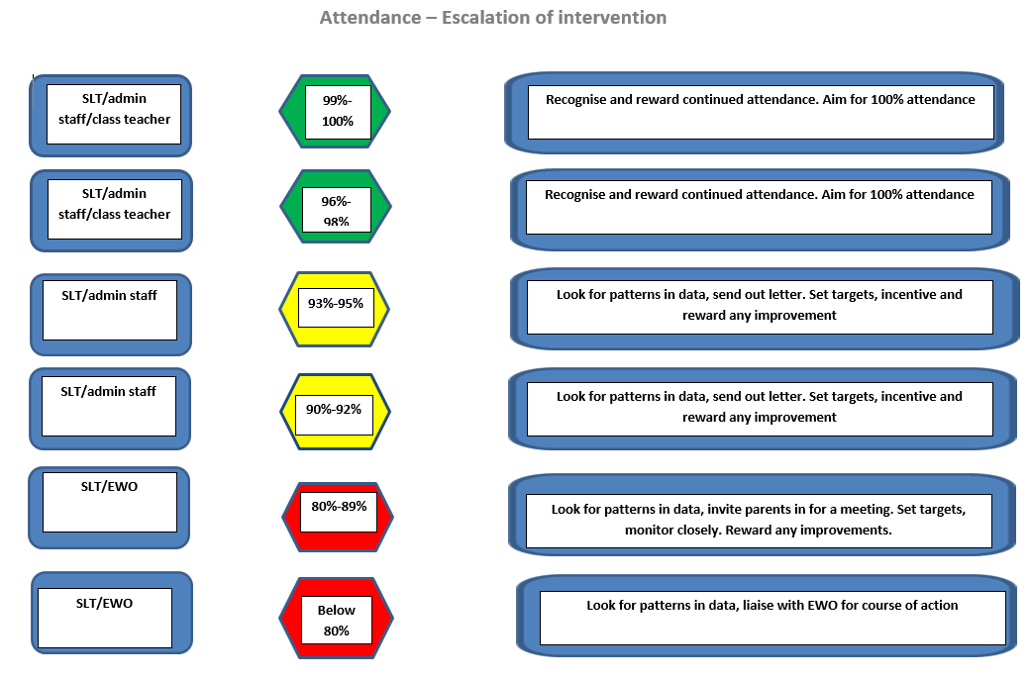

Appendix 4: absence in one school year
