Monday 4th November 2019
Dear Parents / Carers,

Homework

From this week we will be changing the homework that children in Key Stage 1 and 2 will be given each week. We will now be using Times Tables Rockstars and Spelling Shed websites for our weekly homework. All children have their own login information and have been shown how to use these websites by their class teachers. We would like children to logon to each website at least 3 times a week for at least 10 minutes. Children can get onto these websites through any device that is able to access the internet. Children’s personal details are not shown online when using these websites and there is no messaging element to either of them.

Times Tables Rockstars

Your child’s details

Children are allowed to play any of the games within the website but we would like them to focus mainly on Garage and Rock Arena as these games target the particular times tables your child is working on.
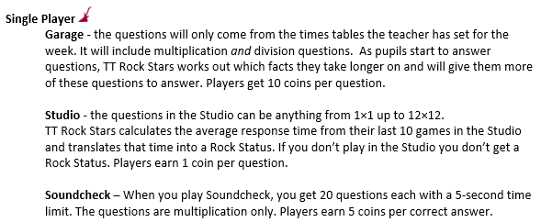

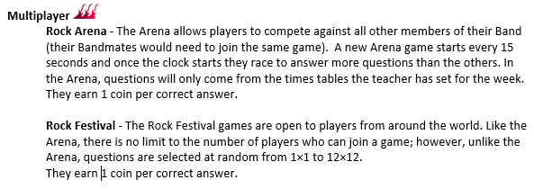
Throughout the year class teachers may set up tournaments between classes and other competitions will be held.

Spelling Shed

Your child’s details

Children in Year 1 and Year 2 should select the Stage 1 & 2 box.
Children in Year 3 and Year 4 should select the Stage 3 & 4 box.
Children in Year 5 and Year 6 should select the Stage 5 & 6 box.

There are a variety of games that children can play. Teachers will set words each week and these will appear in the games. Games may also include words that have not been set that week, but are spellings covered at other times in your child’s year group. Children will still bring spelling lists home each week containing the words for their test on Friday.

There will be lunchtime clubs in school that children can attend if they are struggling to access the websites at home. Paper copies of homework will be sent if children are not taking part in the online homework activities.

If you have any questions please speak to your child’s class teacher.

Yours sincerely

Miss Wilson

