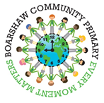

**Our learning challenge this half term!**

**How has man’s desire to conquer space created many heroes and heroines?**

As part of this unit we will be looking at a significant event that happened in the past and we will learn about famous individuals linked to this Topic.

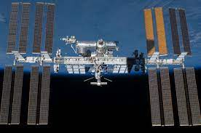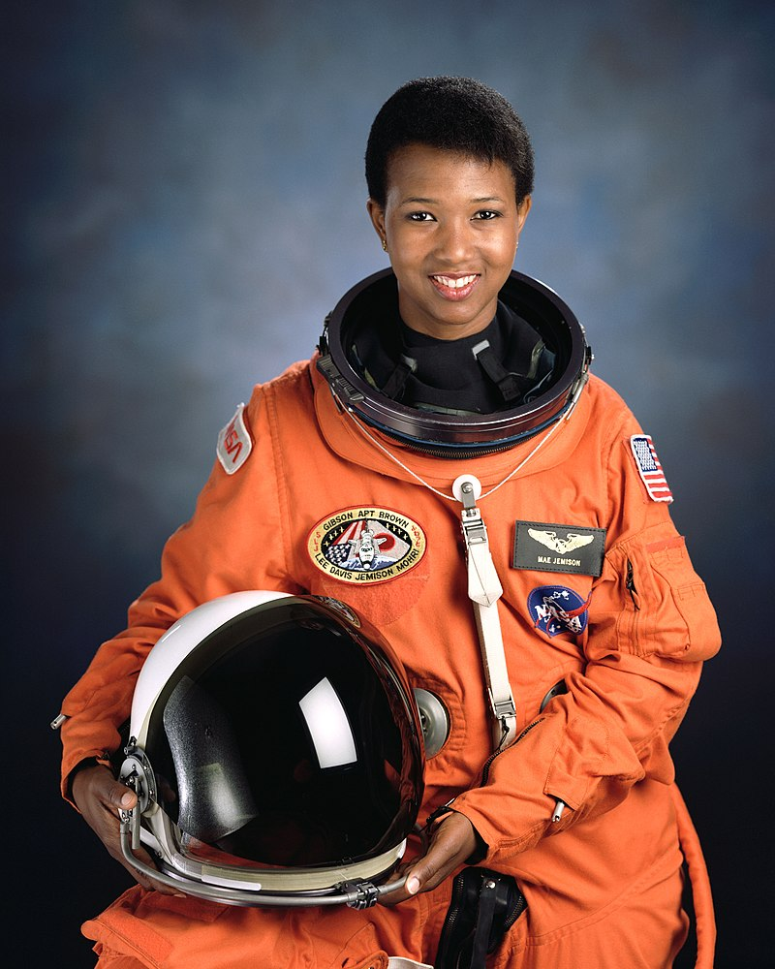

## **Weekly Timetable**

**Monday** – New spellings set for the week

**Tuesday-** Penguins PE Day

**Wednesday** – Penguins and Lobsters PE Day

**Thursday** – Lobsters PE Day

**Friday** – Spelling test in school

**Please sign and return your child’s reading book and record on a daily basis.**

## **Don’t forget to keep up-to-date with our learning by following @BoarshawP on Twitter or by reading our class blog which can be found on the school’s webpage!**



|  |  |  |  |  |  |  |  |  |  |  |
| --- | --- | --- | --- | --- | --- | --- | --- | --- | --- | --- |
|  |  |  |  |  |  |  |  |  |  |  |
|  |  |  |  |  |  |  |  |  |  |  |

## **Don’t forget to keep up-to-date with our learning by following @BoarshawP on Twitter or by reading our class blog which can be found on the school’s webpage!**



**Year 2 - Class Newsletter**

**Autumn 1**

Dear Parents and Carers,

A warm welcome back to school and to Year 2! We are very excited to see how much the children have grown over the summer and look forward to all the exciting things we will be doing together this year.

During the first week back we will be handing out reading books and our key focus will be on ensuring all pupils read at home daily. Please sign and date your child’s reading record whenever they read at home.

Our maths and spelling homework will be online this year using Numbots and Spelling Shed. New spellings will be set on a Monday each week and a spelling test will take place at the end of the week.

Your child needs to bring in their PE kit this week and also a water bottle, which they can use in class.

If you are not connected to Class Dojo, please let us know as soon as possible and we can send you an invitation. We will regularly be in touch through Dojo so it essential you stay connected.

Any questions, please let us know.

Kind regards,

Miss Plant (Penguins) and Mrs Greenhalgh (Lobsters).

|  |  |
| --- | --- |
| **Our learning this half term!** | |
| **English:** | Narrative, letter and poetry. |
| **Maths:** | Place value, addition and subtraction. |
| **Reading:** | The Wolf’s Story: What Really Happened to Little Red Riding Hood. |
| **History** | How has man’s desire to conquer space created many heroes and heroines? |
| **Science** | Living things and their habitats. |
| **Computing** | Coding. |
| **Design and Technology** | Design and create a wrap. |
| **RE:** | Why do we need to give thanks? |
| **PSHE:** | Me and my relationships. |
| **Music:** | Hands, feet, heart. |