Boarshaw Primary School – Science
Topic: Materials |  | Strand: Chemistry |  |  | Year 2
What should I already know? | Key Knowledge |  |  | Key Knowledge
- That an object is something you can see.  - All objects are made of materials.  - Materials have certain properties. | 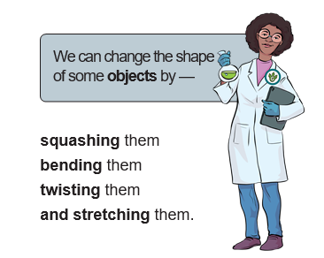 |  |  | 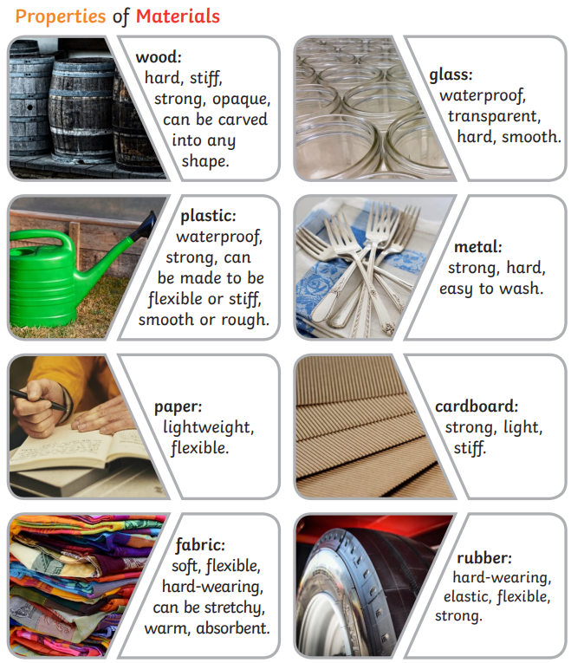
Key Knowledge and Vocabulary

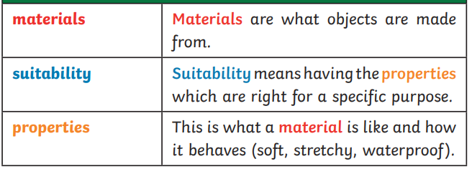
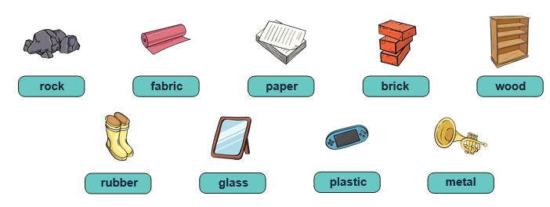

Pre and Post Assessment – Science – Materials and their properties.
 | Start of unit | End of unit |  | Start of unit | End of unit
- Name 3 objects. |  |  | - Explain why glass is a suitable material for a window.
- Name a suitable material for a chair. |  |  | - Explain why metal is a suitable material for a car.
- Name a suitable material for a window. |  |  | - Name two waterproof materials.
- Name a suitable material for a jumper. |  |  | - Name 2 ways to change the shape of a material.

